<Online Learning Platform>

Use-Case Specification: <Grade student>

Version <1.0>

Revision History

| **Date** | **Version** | **Description** | **Author** |
| --- | --- | --- | --- |
| <10/Dec/2021> | 1.0 | Initial version | Nguyen Tuan Nghia |
|  |  |  |  |
|  |  |  |  |
|  |  |  |  |

Table of Contents

1. Use-Case Name 3

1.1 Brief Description 3

2. Flow of Events 3

2.1 Basic Flow 3

2.2 Alternative Flows 3

2.2.1 < First Alternative Flow > 3

2.2.2 < Second Alternative Flow > 3

3. Special Requirements 3

3.1 < First Special Requirement > 3

4. Preconditions 3

4.1 < Precondition One > 3

5. Postconditions 3

5.1 < Postcondition One > 3

6. Extension Points 3

6.1 <Name of Extension Point> 3

Use-Case Specification: <Grade student>

# Use-Case Name

## Brief Description

* *This use case allow teacher to grade student’s submission*
* Subject: Teacher
* This use case helps teachers to manage student scores with ease.

# Flow of Events

## Basic Flow

* First teacher clicks on (GRADE)  button , it leads the teacher to the grading section of the class.
* Teacher can view student’s submission by hovering their mouse to an individual student and click on  button then click on 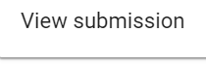 (VIEW SUBMISSION) button. This button will bring teacher to the  (STUDENT ANSWER) section. In this page teacher can see student’s submission:

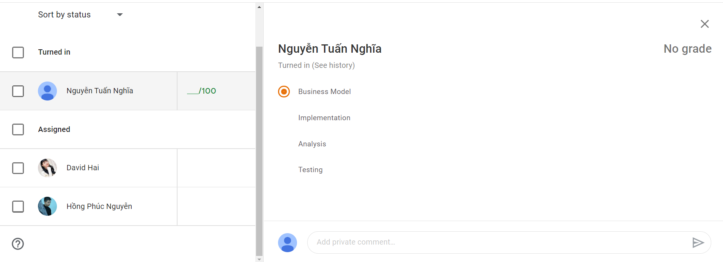

* Teacher can grade student by type the score into 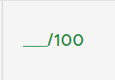 text box. The score input **has to a number,** if teacher input other format but not a number a red warning window (GRADE MUST BE NUMBERS) 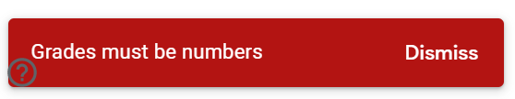will pop up and the user's invalid input will be deleted. Click  (DISMISS) to turn off the pop up window .If teacher input a valid format in the text box, the score will be saved as draft 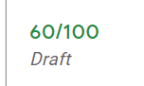 . After the score has been saved click on  (RETURN) button to return score. A pop up window will just to confirm that student can notify and check their grades. Click  (RETURN) button to complete the action or click  (CANCEL) button to discard.

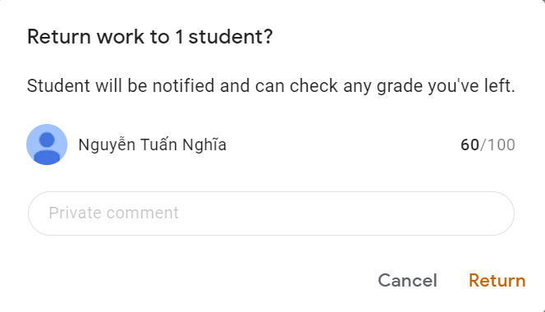

* Teacher can sort Student answer by clicking (SORT) button and choose:

+ Sort by answer (Sort alphabetically)

+ Sort by last name (Sort alphabetically)

+ Sort by first name (Sort alphabetically)

+ Sort by status (To see completed submission first)

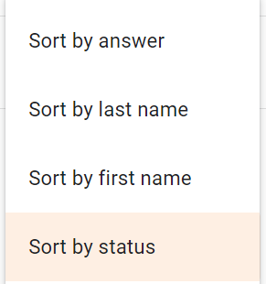

## Alternative Flows

### < First Alternative Flow >

* *[More complex alternatives are described in a separate section, referred to in the* ***Basic Flow*** *subsection of* ***Flow of Events*** *section. Think of the* ***Alternative Flow*** *subsections like alternative behavior⎯ each alternative flow represents alternative behavior usually due to exceptions that occur in the main flow. They may be as long as necessary to describe the events associated with the alternative behavior. When an alternative flow ends, the events of the main flow of events are resumed unless otherwise stated.]*

#### < An Alternative Subflow >

* *[Alternative flows may, in turn, be divided into subsections if it improves clarity.]*

### < Second Alternative Flow >

* *[There may be, and most likely will be, a number of alternative flows in a use case. Keep each alternative flow separate to improve clarity. Using alternative flows improves the readability of the use case, as well as preventing use cases from being decomposed into hierarchies of use cases. Keep in mind that use cases are just textual descriptions, and their main purpose is to document the behavior of a system in a clear, concise, and understandable way.]*

# Special Requirements

* *[A special requirement is typically a nonfunctional requirement that is specific to a use case, but is not easily or naturally specified in the text of the use case’s event flow. Examples of special requirements include legal and regulatory requirements, application standards, and quality attributes of the system to be built including usability, reliability, performance or supportability requirements. Additionally, other requirements⎯such as operating systems and environments, compatibility requirements, and design constraints⎯should be captured in this section.]*

## < First Special Requirement >

# Preconditions

## < Precondition One >

# Postconditions

## < Postcondition One >

# Prototype

**